

**Computer Network**

**Project: Dispatching Company**

**Group Members**

**Hamza Ameen (Bcsm-f20-351)**

**Muhammad Ahmad (Bcsm-f20-353)**

**Ali Arif (Bcsm-f20-384)**

**Section: 5D**

**Submitted To:**

**Mam Maryam**

**Table of Contents**

**Chapter 1**

**Introduction**

**Chapter 2**

**VLSM & Super-netting**

**Chapter 3**

**Virtual LANs**

**Chapter 4**

**ACL**

**Chapter 5**

**Result**

**Chapter 6**

**Conclusion**

**Description**

**Organization:**

**DISPATCH CALL CENTER**

This organization is used to dispatch the trucks internationally in US by having three departments in it which are given below

1:Sales Department

2:Dispatch Department

3:Accounting Department

All departments are connected with single class **C** public IP Address

**Sales Department**

This department contain 3 pcs with one switch and router in which vlsms is applied and data can be sent to other departments individually This department contain IP Address 192.168.10.0 with subnet mask 255.255.255.224

**Dispatch Department**

This department contain 3 pcs with one switch and router in which vlsms is applied and data can be sent to other departments individually This department contain IP Address 192.168.10.32 with subnet mask 255.255.255.240

**Accounting Department**

This department contain 3 pcs with one switch and router in which vlsms is applied and data can be sent to other departments individually This department contain IP Address 192.168.10.48 with subnet mask 255.255.255.248

Chapter 1

Introduction

**Design any organization based topology and configure the design of IPV4 plan by using subletting concept. Select any organization with proper name and departments, and design its specific IP Plan by constructing a table**

**1. Introduction of Topology:**

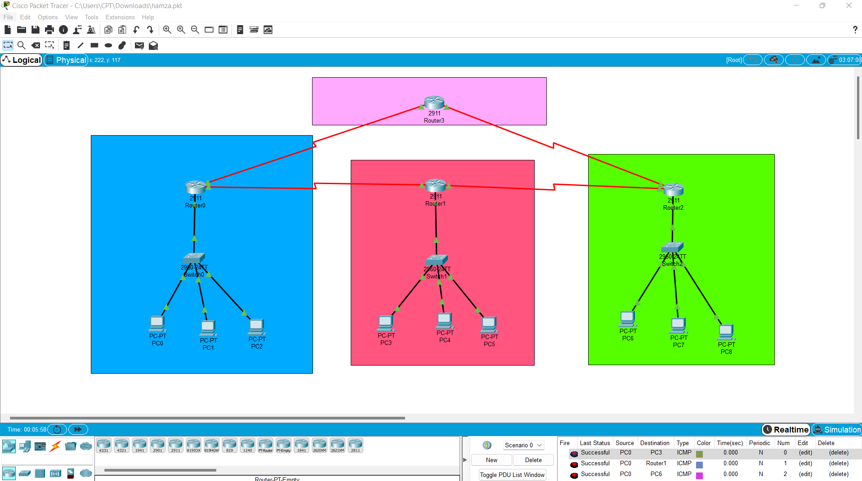

This organization is used to dispatch the trucks internationally in US by having three departments in it which are given below

1:Sales Department

2:Dispatch Department

3:Accounting Department

All departments are connected with single class **C** public IP Address

Plan Template

|  |  |  |  |
| --- | --- | --- | --- |
| Department | Sales | Dispatch | Accounting |
| subnets | 3 | 4 | 5 |
| Subnet mask | 255.255.255.224 | 255.255.255.240 | 255.255.255.248 |
| Net ID | 192.168.10.0 | 192.168.10.32 | 192.168.10.48 |
| First Host IP | 192.168.1.1 | 192.168.10.33 | 192.168.10.49 |
| Last Host IP | 192.168.1.21 | 192.168.10.44 | 192.168.10.54 |
| Broadcast ID | 192.168.10.31 | 192.168.10.47 | 192.168.10.55 |
| Host Range | 192.168.1.1-192.168.1.21 | 192.168.10.33-  192.168.10.44 | 192.168.10.54-  192.168.10.55 |

--------------------Chapter 2---------------------

VLSM & Super-Netting

Introduction:

**Variable length Subnet Mask** (VLSM) is a segmented large network design which occurs when internetwork uses more than one mask for different subnets of single mask

**Super-netting** is a process of summarizing a bunch of contiguous subnetted networks back in single large network

|  |  |  |  |
| --- | --- | --- | --- |
| Host/department | Sales | Dispatch | Accounting |
| Subnet | 3 | 4 | 5 |
| Subnet Mask | 255.255.255.224 | 255.255.255.240 | 255.255.255.248 |
| Network ID | 192.168.10.0 | 192.168.10.32 | 192.168.10.48 |
| First Host IP | 192.168.1.1 | 192.168.10.33 | 192.168.10.49 |
| Last Host IP | 192.168.1.21 | 192.168.10.44 | 192.168.10.54 |
| Broadcast IP | 192.168.10.31 | 192.168.10.47 | 192.168.10.55 |
| Host Range | 192.168.1.1-192.168.1.21 | 192.168.10.33-  192.168.10.44 | 192.168.10.54-  192.168.10.55 |

--------------Chapter 3-----------------

Virtual LANs

Introduction:

VLANs = logically segmented (Broadcast Domain)

**Advantage of VLANs**

1:Broadcast Control

2:Security

3:Flexibilty

We use vlans in our project to make secure our data transfer to the other system

Vlans applied on switches which make our data transfer efficiently so that’s the reason we use vlans in our switches because it increases the security and flexibility of the system

Updated Topology for VLANs:

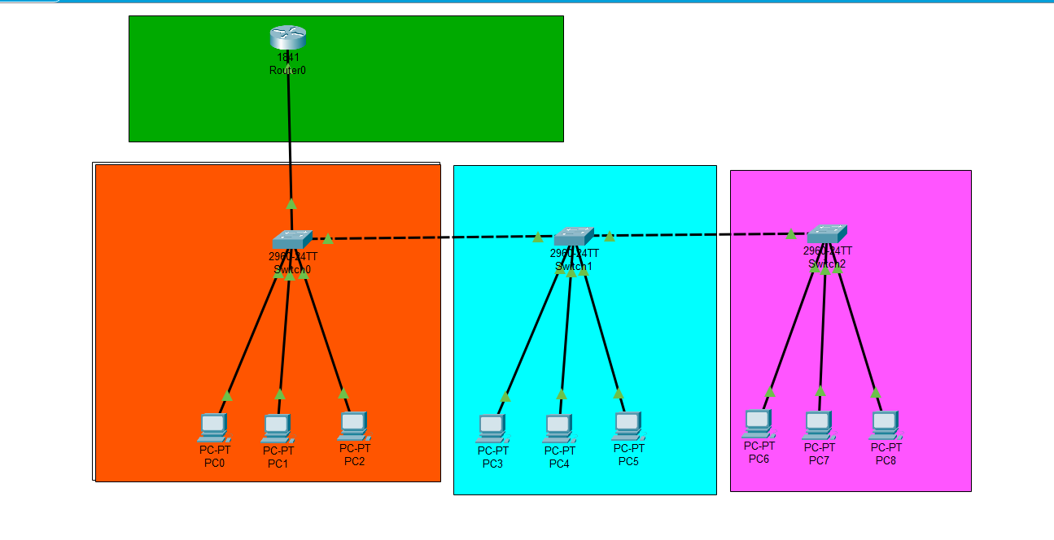

**----------------Chapter 4-----------------**

**Access Control List**

**Introduction:**

ACL = Condition Applied(Traffic Control)

* It mainly Controls the Routers
* Control traffic ingoing or outgoing
* It is also Known as Packet Filtering

We use ACL in our project to make secure our data which is to be send through the routers and block the unnesscary traffic which passed thorugh the routers

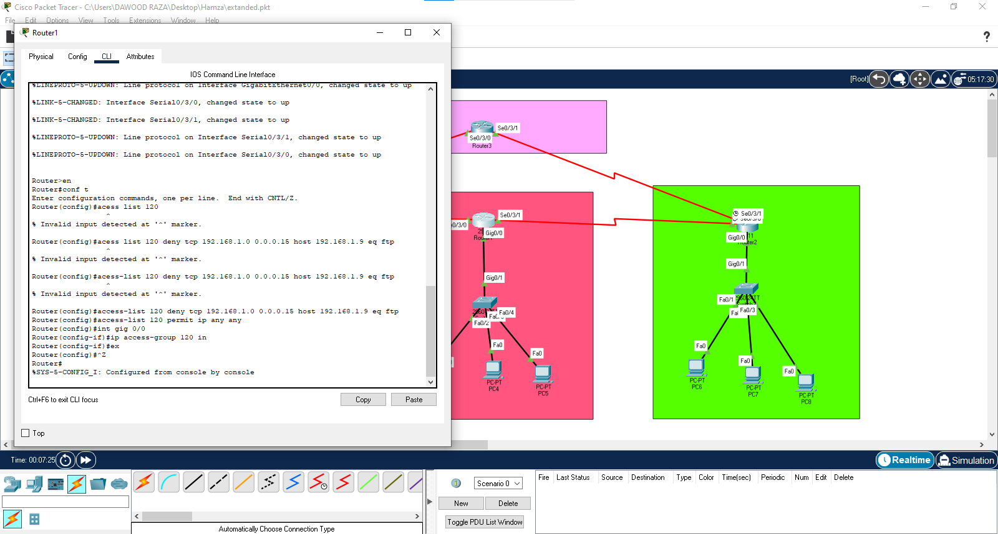

|  |  |  |  |  |
| --- | --- | --- | --- | --- |
| Access list | department | Acl type | IP block Range |  |
| 192.168.1.1 | 1 | Extended | 100-199 |  |
| 192.168.1.31 | 2 | Extended | 100-199 |  |
| 192.168.1.45 | 3 | Extended | 100-199 |  |

**---------------------Chapter 5---------------------**

**Results**

**Result of VLSM**



Result of VLANS

* 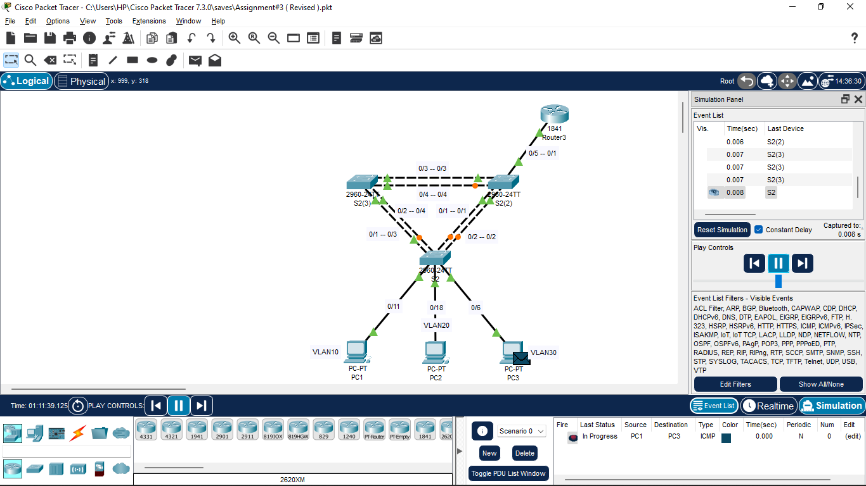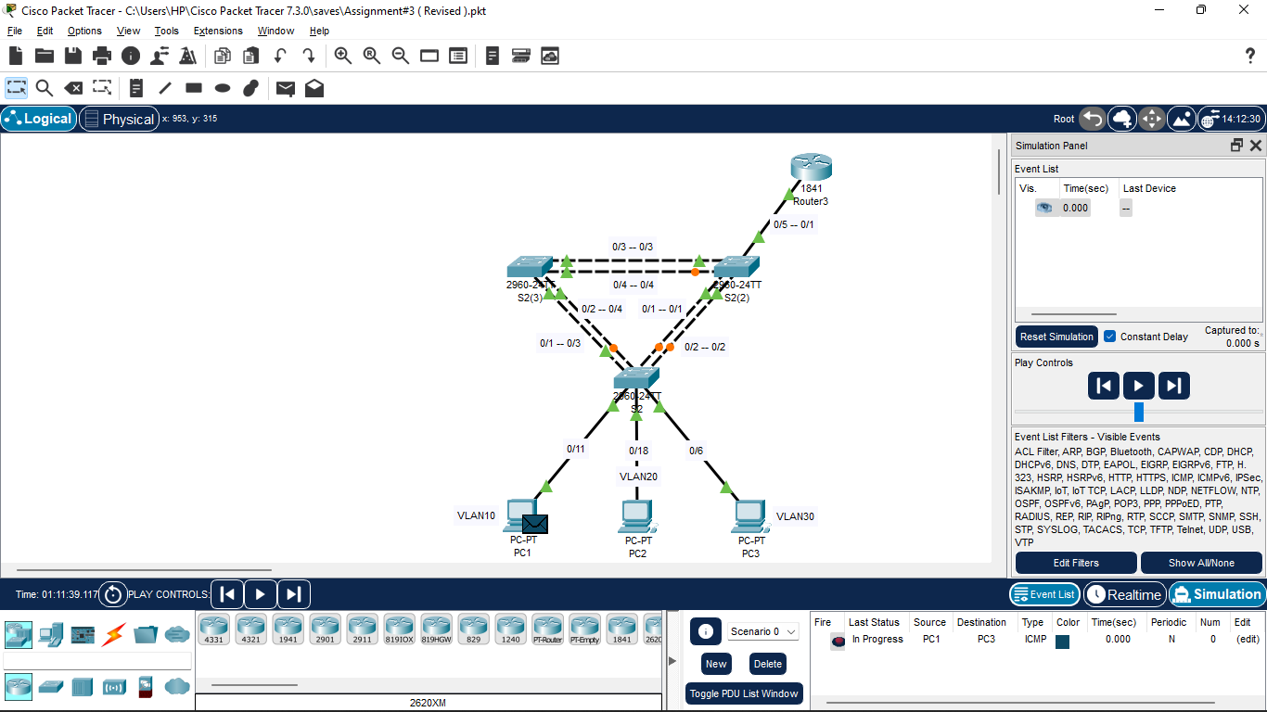**, PC1 must be able to ping to PC3.**

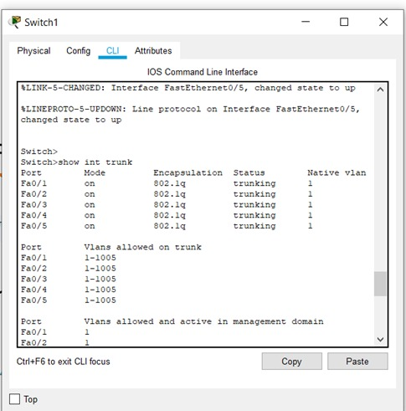Switch 1:

Result ACL:

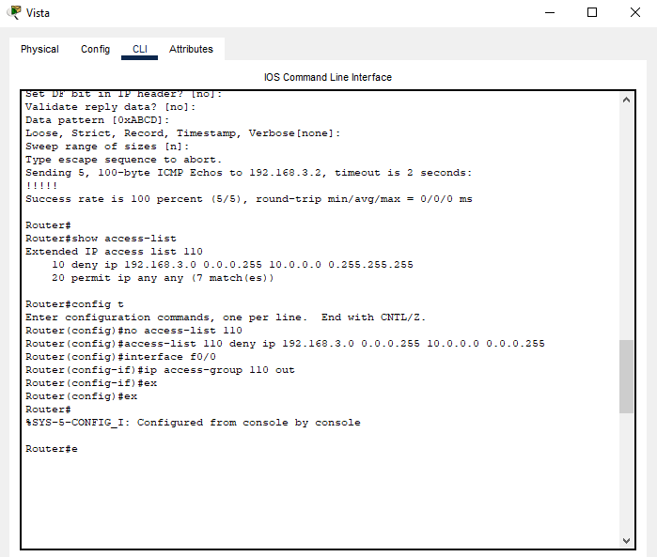

STANDARD ACL:

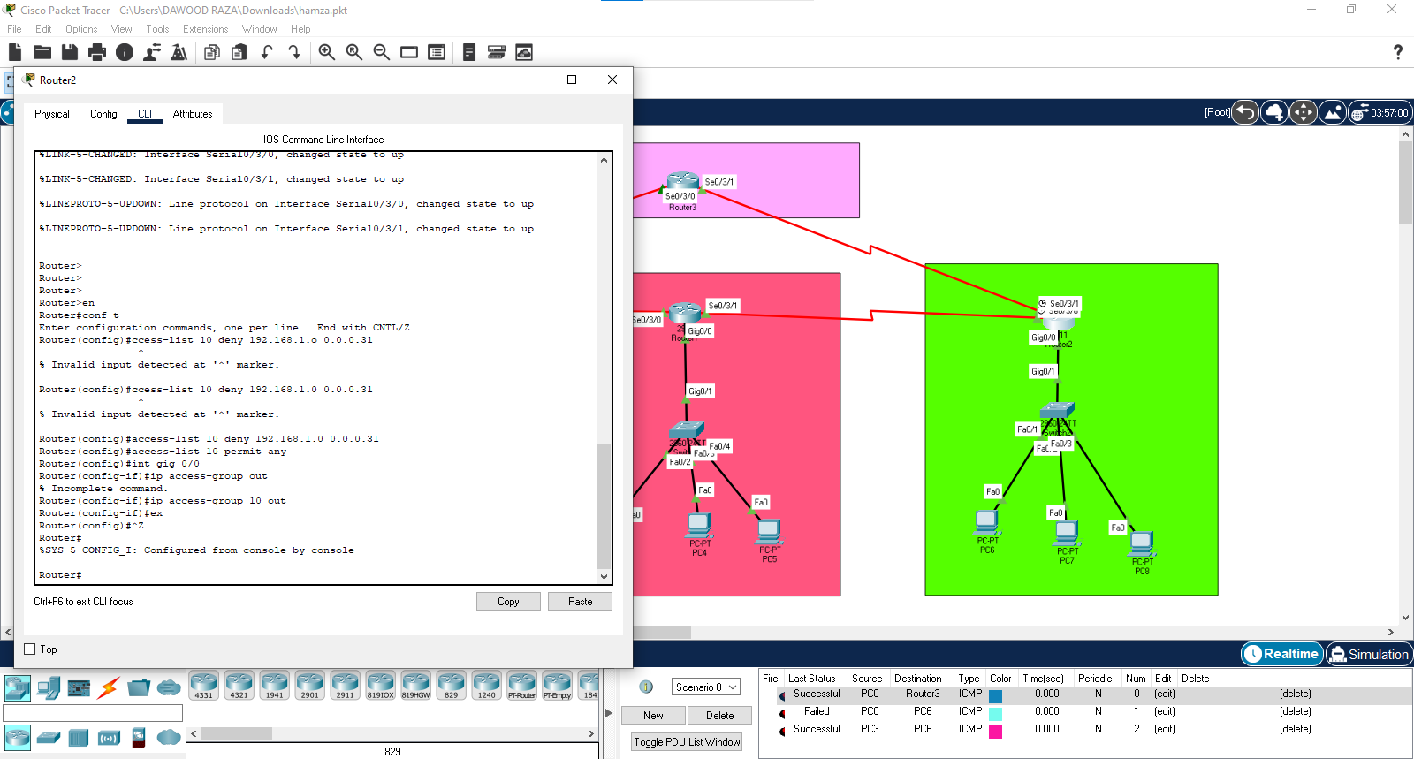

EXTENDED ACL:



-------------------Chapter 6------------------

Conclusion

Our project is based on dispatching organization which is using vlans,vlsm,and acl networking components which make our data secured and efficient to send the data to the other system

In this way we have 3 departments and we send data from one department to the other department securely